A Hybrid CNN-Transformer Approach for Breast Cancer Detection and Segmentation from Ultrasound Images

CN7000 MWPL Mental Wealth and Professional Life Dissertation

University of East London

School of Architecture, Computing and Engineering

Author: Kumarage Nimsha Erin
Student ID: S1035533, U2781408
Supervisor: Dr Preethi Kesavan

Contents

1 Introduction 3
1.1 Dissertation Ideation Summary 3
1.2 Background 3
1.3 Purpose 3
1.4 Aim 3
1.5 Objectives 3
2 Literature Review 4
2.1 Research Area 4
2.2 Venn Diagram 4
3 Methodology 5
3.1 Expected Practical Element Output 7
3.2 Required Resources 7
3.3 Prerequisite Knowledge/Skills Required. 7
3.4 Data Source. 8
4 Legal, Social, Ethical and Professional Practice 9
5 Planning 10
References 10
Annex A – Schedule of Work Gantt Chart 11

Table of Figures

Figure 1-Venn Diagram 5
Figure 2-DSRM Diagram 6
Figure 3-SDLC Diagram 7
Figure 4-Data Source 9
Figure 5-Research Timeline 10
Figure 6-Ghantt Chart 12

Introduction

Breast cancer remains one of the most common causes of cancer-related mortality among women. Early detection of breast cancer is crucial for preferable outcomes except ultrasound imaging faces drawbacks like speckle noise, low contrast, and operator dependency. This project introduces a Hybrid CNN-Transformer model, combining CNNs and Vision Transformers (ViTs) to improve breast cancer detection and segmentation.

Dissertation Ideation Summary

Early detection and diagnosis improve treatment outcomes. However, it requires expert interpretation while using traditional methods like, mammography and ultrasound to find out variability in diagnosis (Bunnell & Sargeant, 2023). Recent enhancements in Deep Learning (DL) and Artificial Intelligence (AI) offer a positive infusion with breast cancer detection and segmentation (Chowa et al., 2023). This dissertation dives into a Hybrid CNN-Transformer model, that combines CNNs for spatial relationships in ultrasound images.

Background

Breast cancer detection and segmentation using ultrasound images have caught a remarkable attention recently due to their potential for early diagnosis. Deep learning methods like, CNNs and Transformers, have shown momentous results in this area (Hossain & K, 2023; Golla & Madhu, 2024). In additionally, hybrid approaches that combines CNNs with Transformer models offer enhanced performance in both classification and segmentation tasks (Alruily, 2024). Therefore, recent studies (Kumar & S, 2024; Ragab et al., 2022) highlight the promising improvement of accuracy using these techniques for better diagnostic outcomes.

Purpose

Breast cancer detect by ultrasound imaging indicates substantial drawbacks due to high noise, variance, and inter-class parallels. Therefore, the purpose of this research is to implement an advanced AI-driven approach of a hybrid CNN-Transformer model for breast cancer classification and segmentation.

Aim

This study aims to enhance diagnostic accuracy and provide explainable AI solutions for medical professionals that contributes to more reliable and efficient breast cancer detection.

Objectives

Key objectives of this study focusing on leveraging state-of-the-art deep learning models to improve diagnostic accuracy, optimize feature selection, and integrate advanced techniques. The objectives are to:

- Develop a hybrid deep learning model integrating CNN-based feature extraction and Transformer-based spatial analysis (Ferreira, 2023).
- Evaluate model performance using Experimental Research methodology, applying publicly available breast ultrasound datasets (Hossain & Kumar, 2023).
- Differentiate segmentation results with benchmark models such as U-Net and UCapsNet (Madhu & Malapati, 2024).
- Provide model explain ability using techniques like Grad-CAM and Transformer attention visualization (Karimzadeh, 2023).
- Analyse clinical feasibility and real-world applicability with experimental validation and radiologist assessments (Chia & Seng, 2025).
- Build a full-stack software platform that integrates the AI model into a web-based system for automated breast cancer detection (Olawade and C.-O., 2025).
- Deploy the platform using Python for backend, Vue.js for frontend, and MySQL for database management to enable real-time ultrasound image analysis (Ferreira, 2023).

Literature Review

This section explores existing research in breast cancer detection, highlighting key methodologies, challenges, and innovations to establishes a foundation for the proposed Hybrid CNN-Transformer approach which demonstrate its potentiality to enhance diagnostic precision and segmentation performance.

Research Area

This research falls within the area of Artificial Intelligence (AI) in Medical Imaging that focus on deep learning techniques for breast cancer detection. As the major areas of the research,

- Computer Vision & Deep Learning: CNNs for feature extraction and Vision Transformers for long-range dependencies (Ferreira, 2023).

- Medical Image Segmentation: U-Net, attention mechanisms, and hybrid models for improving lesion boundary detection (Sultana Chowa et al., 2023).

- Explainable AI (XAI) in Healthcare: Enhancing AI interpretability using Grad-CAM, SHAP, and Transformer attention visualization (Karimzadeh, 2023).

- Software Development & Deployment: Building an AI-powered diagnostic platform using Python, Vue.js, and MySQL to enable seamless integration in clinical environments (Ferreira, 2023).

Venn Diagram

The interdisciplinary nature of this study integrates:
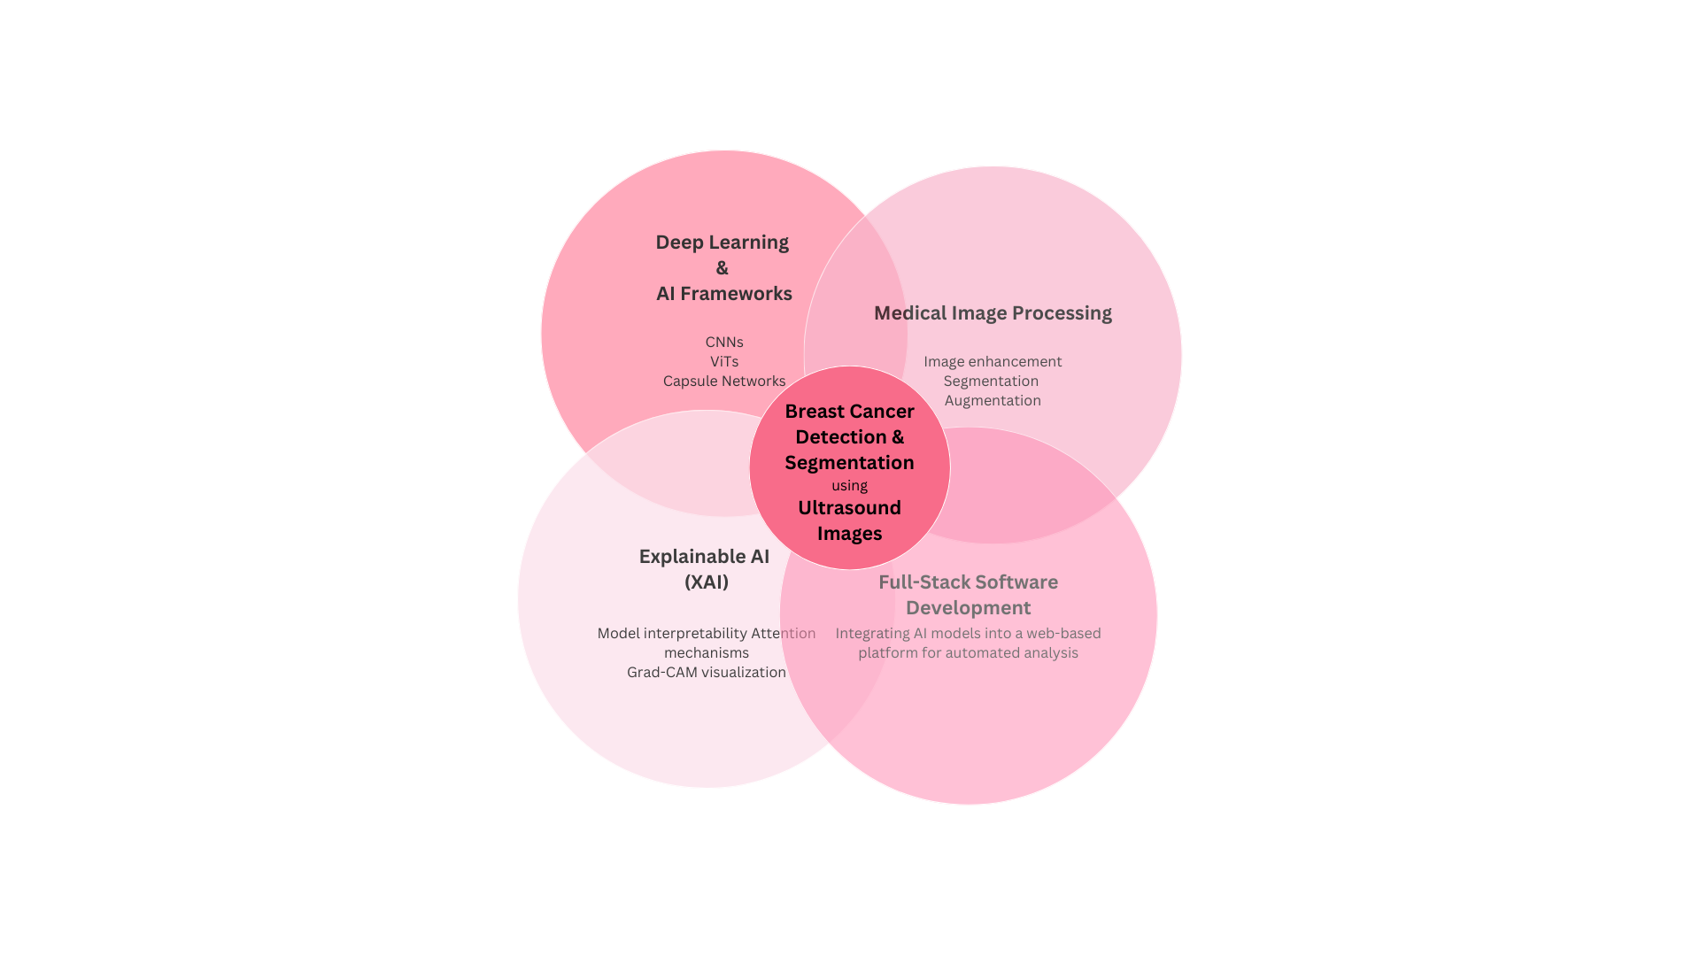
Figure 1-Venn Diagram

Methodology

This study adopts a hybrid methodology combining Experimental Research (Schoormann et al., 2023) for model evaluation and Software Development Lifecycle (SDLC) for platform implementation.

Justification:

- Experimental Research using Peffers et al.’s DSRM allows controlled testing of different AI architectures on medical imaging datasets (Sultana Chowa et al., 2023; Premananda, Tjahyanto and Mukhlason, 2022).
- Software Development ensures practical implementation by integrating the AI model into a functional diagnostic platform (Ferreira, 2023).
- This methodology aligns with AI-driven healthcare research (Hossain & Kumar, 2023; Ferreira, 2023).

Design Science Research Methodology

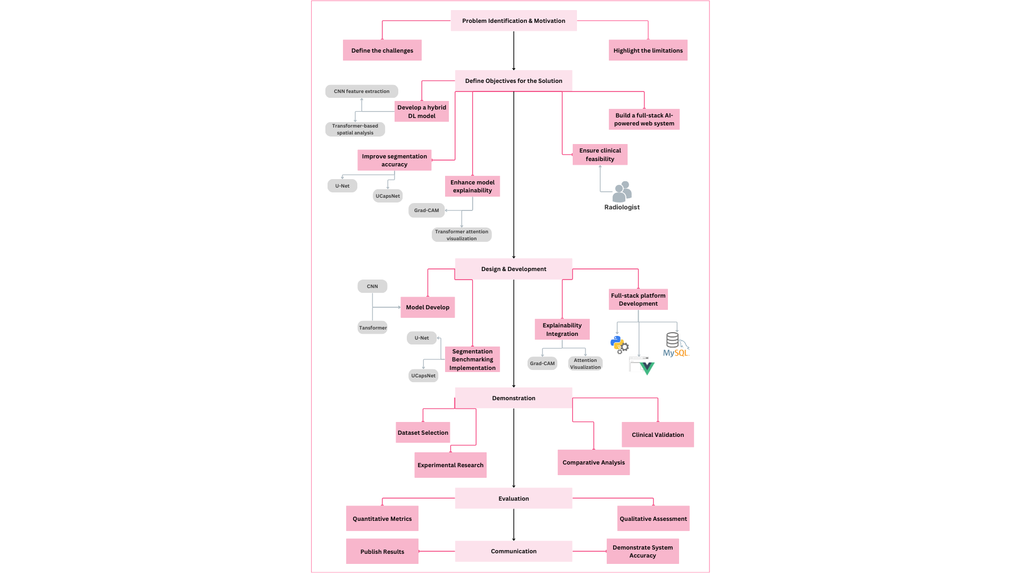
Figure 2-DSRM Diagram

Software Development Lifecycle (SDLC) for AI Platform using Agile-Waterfall (Prakash, 2024):

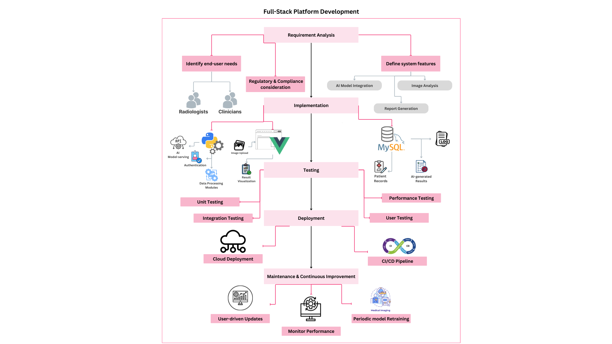
Figure 3-SDLC Diagram

Expected Practical Element Output

The research bridges AI and clinical applications by providing an efficient, scalable, and interpretable solution for breast cancer detection in ultrasound imaging. Expected outcomes includes,
- A robust deep learning model for classification and segmentation (Ferreira, 2023).
- A Python-Vue.js-MySQL-based software system for real-time analysis (Chia and Seng, 2025).
- Enhanced interpretability using Grad-CAM and Transformer Attention Maps (Karimzadeh, 2023).
- Comparative evaluation with U-Net and UCapsNet ensures accuracy improvements (Madhu and Malapati, 2024).
- Cloud deployment enables real-world usability and remote diagnostics (Alruily and Malapati, 2024).

Required Resources

- Computational Requirements: High-performance GPU-powered systems for training large-scale models in Cloud-based platforms such as Google Colab, AWS (Chia and Seng, 2025).
- Software & Libraries: Use of TensorFlow/PyTorch, OpenCV, Sci-Kit Learn, FastAI, Grad-CAM (Ferreira, 2023).
- Additional Libraries: Use of FastAI and Grad-CAM for enhancing model explainability (Karimzadeh, 2023).
- Data Annotation Tools: LabelImg, Label Studio.
- Medical Experts Consultation for model validation and feasibility studies (Chia & Seng, 2025).

Prerequisite Knowledge/Skills Required

For the success of this project requires expertise in multiple domains,

- Deep Learning and Computer Vision: Knowledge of CNNs, ViTs, and hybrid deep learning models is essential for implementing the classification and segmentation framework (Ferreira, 2023). Familiarity with attention mechanisms and transfer learning techniques is also required (Karimzadeh, 2023).
- Medical Imaging Techniques: Understanding ultrasound imaging principles, tumour characteristics, and pre-processing techniques such as denoising and contrast enhancement is necessary for improving data quality (Bunnell and Sargeant, 2023).
- Model Evaluation & Performance Metrics: Experience with performance assessment techniques, including accuracy, F1-score, AUROC for classification, and Dice Coefficient and IoU for segmentation, is critical for benchmarking model effectiveness (Hossain and Kumar, 2023).
- Explainable AI (XAI) and Model Interpretability: Implementing Grad-CAM, SHAP, and attention visualization techniques is essential for enhancing model explainability and clinical acceptance (Chia and Seng, 2025).
- Software Development & Full-Stack Engineering: Proficiency in Python (Flask/Django) for backend, Vue.js for frontend, and MySQL for database management is necessary for developing and deploying the AI-powered diagnostic platform (Madhu and Malapati, 2024).
- Ethical AI Deployment & Data Privacy: Understanding bias mitigation, regulatory compliance (HIPAA & GDPR), and patient data security measures is crucial for responsible AI adoption in healthcare (Al-Okaily, 2020).

By leveraging expertise in these domains, the project aims to develop an effective, interpretable, and clinically viable detection system.

Data Source

Dataset: Publicly available Breast Ultrasound Dataset (BUD) from Kaggle (Al-Dhabyani et al., 2020).

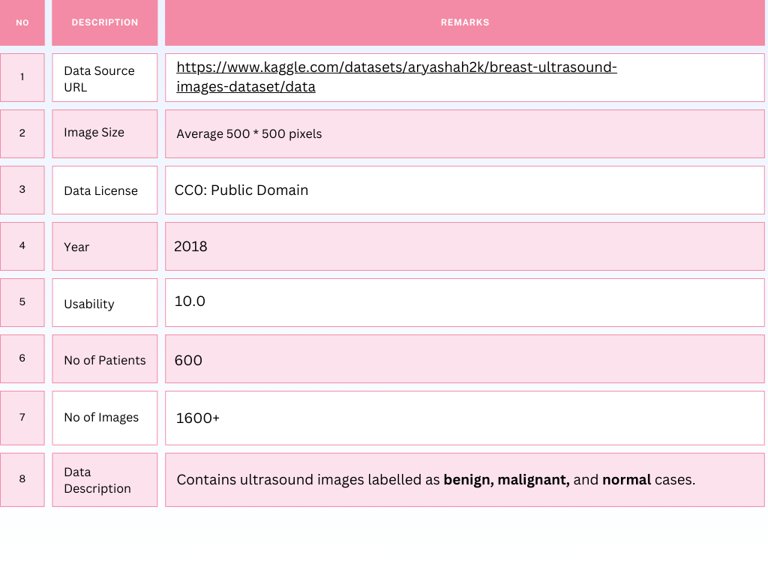
Figure 4-Data Source
Preprocessing:
- Data augmentation (rotation, flipping, contrast enhancement).
- Noise reduction using Wavelet Transform (Sultana Chowa et al., 2023).
- Annotation refinement for segmentation masks.

Legal, Social, Ethical and Professional Practice

The development of AI-driven medical imaging solutions must consider legal, ethical, and professional standards to ensure trust, fairness, and compliance. Data privacy and security require adherence to GDPR and HIPAA regulations, with secure data storage and encryption to prevent breaches (Al-Okaily, 2020; Chia and Seng, 2025). Bias and fairness are addressed through diverse datasets and fairness-aware learning to prevent diagnostic disparities (Bunnell and Sargeant, 2023).

Explainability and trustworthiness are improved using Grad-CAM and Transformer Attention Maps, improving transparency for medical professionals (Karimzadeh, 2023). Ethical AI deployment follows FAT-ML principles, ensuring human oversight to prevent AI over-reliance (Madhu and Malapati, 2024). Regulatory compliance and validation with FDA and EMA guidelines are crucial, with radiologists aiding external validation for robustness (Ferreira, 2023).

Professional responsibility represents fairness, accountability, and transparency, preventing AI misinterpretation in diagnostics (Hossain and Kumar, 2023). By addressing these challenges, this project aims to create a secure, ethical, and clinically viable AI system for breast cancer detection in ultrasound imaging.

Planning

Project Timeline:
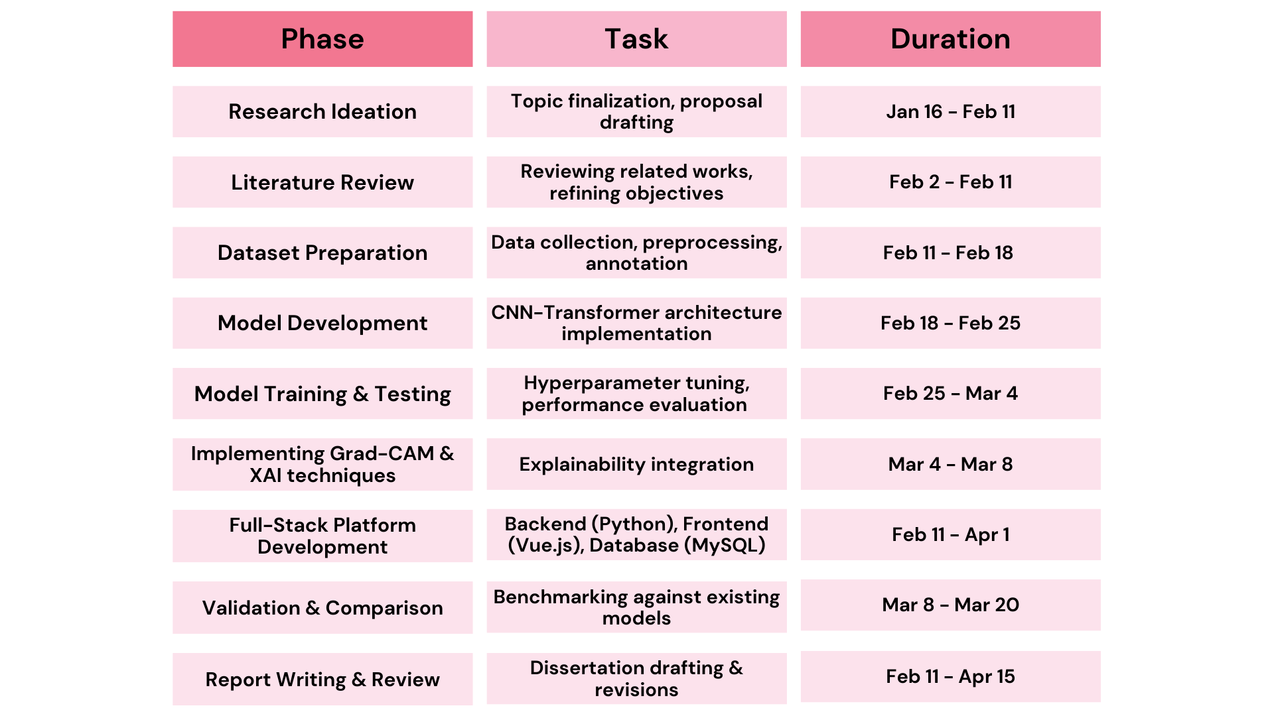
Figure 5-Research Timeline
Risk Assessment:
- Computational Constraints: Large-scale deep learning models require high-end GPUs (Chia & Seng, 2025).
- Data Availability: Limited labelled datasets for segmentation tasks.
- Clinical Adoption Challenges: Acceptance by radiologists and hospitals (Bunnell & Sargeant, 2023).

References

A. B. M. Aowlad Hossain, J. K. (2023). Breast Cancer Classification from Ultrasound Images using VGG16 Model based Transfer Learning. Graphics and Signal Processing, 12-22.
Al-Dhabyani, W., Gomaa, M., Khaled, H. and Fahmy, A. (2020) ‘Dataset of breast ultrasound images’, Data in Brief, 28, p. 104863. doi:10.1016/j.dib.2019.104863.
Al-Okaily, M. (2020). The Determinants of Digital Payment Systems’ Acceptance under Cultural Orientation Differences: The Case of Uncertainty Avoidance . Technology in Society, 63.
Amit Kumar, R. S. (2024). A Comparative Analysis of Machine Learning Algorithms for Breast Cancer Detection and Identification of Key Predictive Features. Traitement du Signal, pp. 127-140 .
Arianna Bunnell, P. S. (2023). EARLY BREAST CANCER DIAGNOSIS VIA BREAST ULTRASOUND AND DEEP LEARNING. Arianna Bunnell.
David B. Olawade, A. C.-O. (2025). Integrating AI into Cancer Immunotherapy—A Narrative Review of Current Applications and Future Directions. Diseases, 13-24.
Ferreira, A. M. (2023). Breast Tumor Segmentation and Classification using Deep Learning Methods. Masters Dissertation: Master’s in Informatics Engineering.
Golla Madhu, A. M. (2024). UCapsNet: A Two-Stage Deep Learning Model Using U-Net and Capsule Network for Breast Cancer Segmentation and Classification in Ultrasound Imaging. Cancers.
Jolene Li Ling Chia, G. S. (2025). Harnessing Artificial Intelligence to Enhance Global Breast Cancer Care: A Scoping Review of Applications, Outcomes, and Challenges. Cancers, 1-28.
Karimzadeh, M. (2023). An Explainable Multi-Task Neural Network Model for Breast Cancer Detection in Ultrasound Images. A Thesis Presented in Partial Fulfillment of the Requirements for the Degree of Master of Science .
Mahmoud Ragab, A. A. (2022). Ensemble Deep-Learning-Enabled Clinical Decision Support System for Breast Cancer Diagnosis and Classification on Ultrasound Images. Biology, 439.
Meshrif Alruily, A. M. (2024). Enhancing Breast Cancer Detection in Ultrasound Images: An Innovative Approach Using Progressive Fine-Tuning of Vision Transformer Models. International Journal of Intelligent Systems, 18.
Prakash, M., 2024. Role of Generative AI Tools (GAITS) in Software Development Life Cycle (SDLC) - Waterfall Model. Massachusetts Institute of Technology. ProQuest Dissertations & Theses, (31652432).
Premananda, I.G., Tjahyanto, A. and Mukhlason, A. (2022) ‘Design Science Research Methodology and its application to developing a new timetabling algorithm’, IEEE Conference Proceedings, Piscataway: The Institute of Electrical and Electronics Engineers, Inc. doi:10.1109/CyberneticsCom55287.2022.9865661.
Sadia Sultana Chowa, S. A. (2023). Graph neural network‑based breast cancer diagnosis using ultrasound images with optimized graph construction integrating the medically significant features. Journal of Cancer Research and Clinical Oncology, 149:18039–18064.
Schoormann, T., Möller, F., Di Maria, M. and Große, N. (2023) ‘Guiding design principle projects: A canvas for young design science researchers’, Journal of Information Systems Education, 34(3), pp. 307–325.*

Annex A – Schedule of Work Gantt Chart

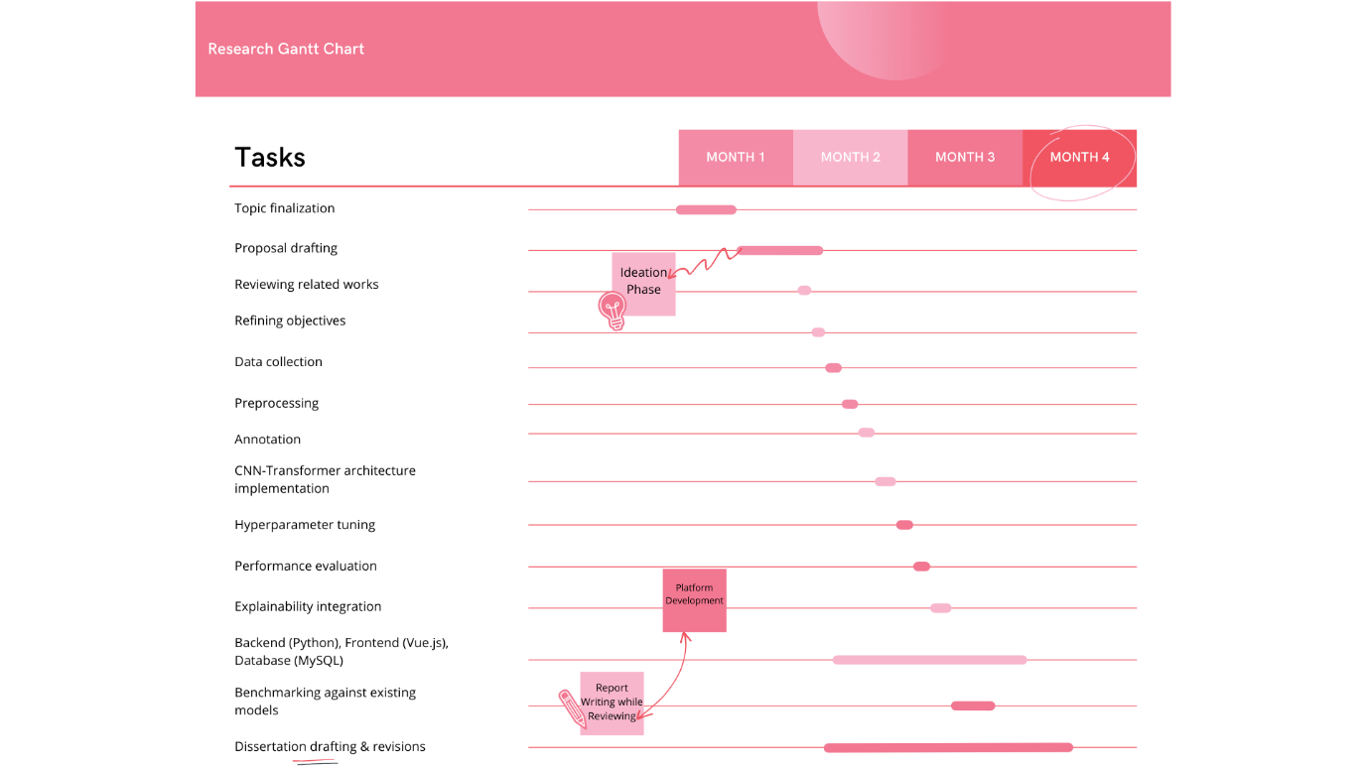
Figure 6-Ghantt Chart

